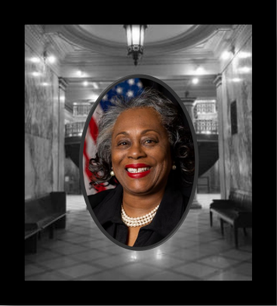**Designate ANN C. LEWIS For MONROE COUNTY CLERK**

**There must be; Accountability, Integrity, & Transparency within the Monroe County Clerk office.**

**Dear MCDC Committee Member:**

**I pray all is well. My name is Ann C. Lewis, and I am hoping I can gain your designation for the office of Monroe County Clerk. I have lived in the Cornhill neighborhood for over 30 years, within the city of Rochester. Currently, I serve as the Program Administrator for The Gun Violence Prevention Hub. In 2021 I retired from the Rochester City School District, from the position of Special Education Teacher. I am the mother of four adult children and the proud grandmother of five. I have a Bachelor Degree in Sociology, which I secured from Buffalo State College. Additionally, I have two Masters, one in Public Administration, earned at Brockport State College, and the second Masters in Education, which I secured from Roberts Wesleyan College.**

**There has always been an inner drive within me, to help improve the lives of others. I have always had a love for public service work. Prior to retiring from the Rochester City School District, I worked for 16 years as a Rehabilitation Counselor for the Monroe County Sheriff Department, and prior to that, five years as Victim Service Worker with the Rochester Police Department.**

**People who know me personally and professionally describe me as a, “Think out of the Box” problem solver, who is a persistent advocate, who works hard to ensure all individuals are provided an equal playing field, that allows them to thrive. I am pleased to say, to totally agree with that summation of my priorities.**

**I strongly believe, all residents within Monroe County have the right to have an individual in the Monroe County Clerk’s office who is focused upon ensuring their legal records and tax appropriations are maintained and applied as expected. All towns and the inner city of Rochester should have equal access to all County resources, and not be just a last consideration.**

**Background**

**Education: MS Degree Public Administration, SUNY Brockport, MS Degree Education, Roberts Wesleyan College, BA Degree ARTS in Sociology, State University at Buffalo Work Experience: Retired Special Education Teacher, Former Rehabilitation Counselor, Monroe County Sheriff Dept., Victim Service Worker Rochester Police Department Community Service: Member of Aenon Baptist Church Missionary Society, member of Delta Sigma Theta Sorority Inc., member of Cornhill Neighborhood Association- Philanthropy Committee. Family: Proud mother of four adult children: Kitia, Montgomery, twins Gino and Clarissa. Contact Information or to send a campaign donation: mailing address: Attention- Ann C. Lewis 350 Clarissa Street, Rochester N.Y. 14608, (585) 736-0551, annlewis48@hotmail.com**